Function 1 – Log in to account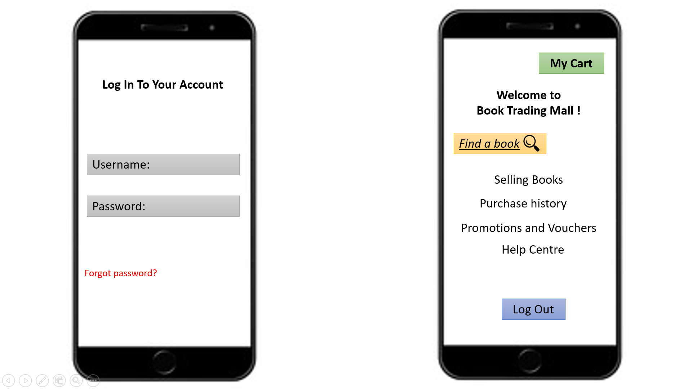 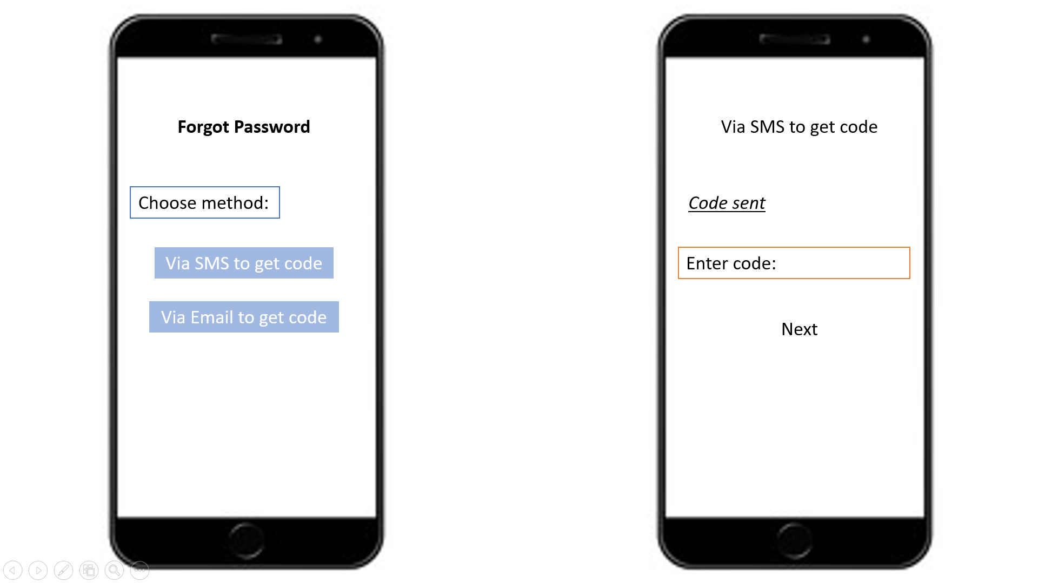

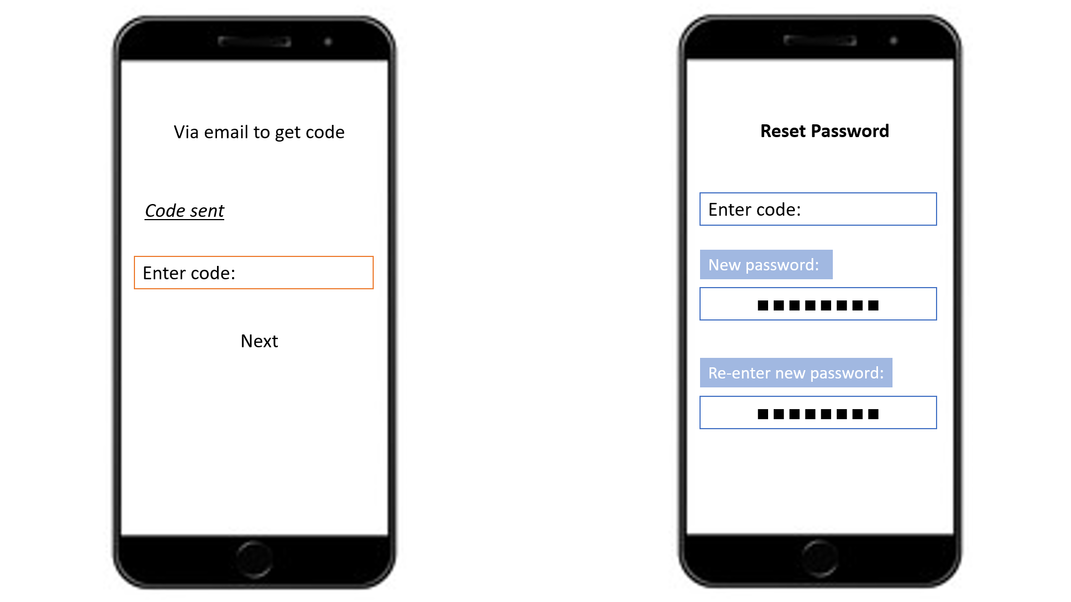

1. How to log in account?

2. What page will pop up after successful log in?

3. Which method to get code when forgot password?

4. How to get code via SMS?

5. How to get code via email?

6. How to reset password?

Function 2: Find a help

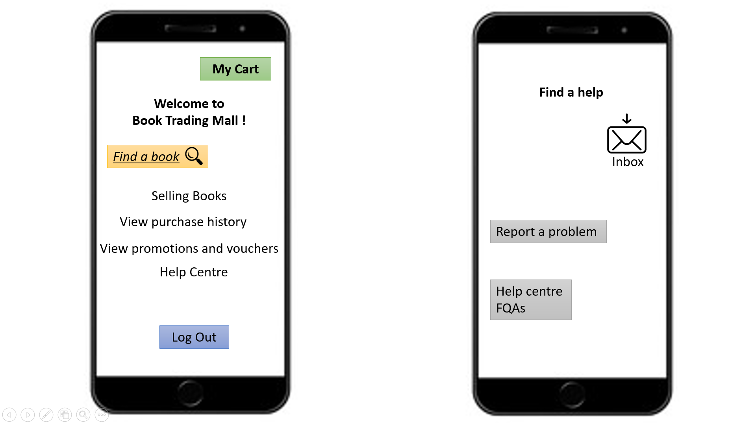 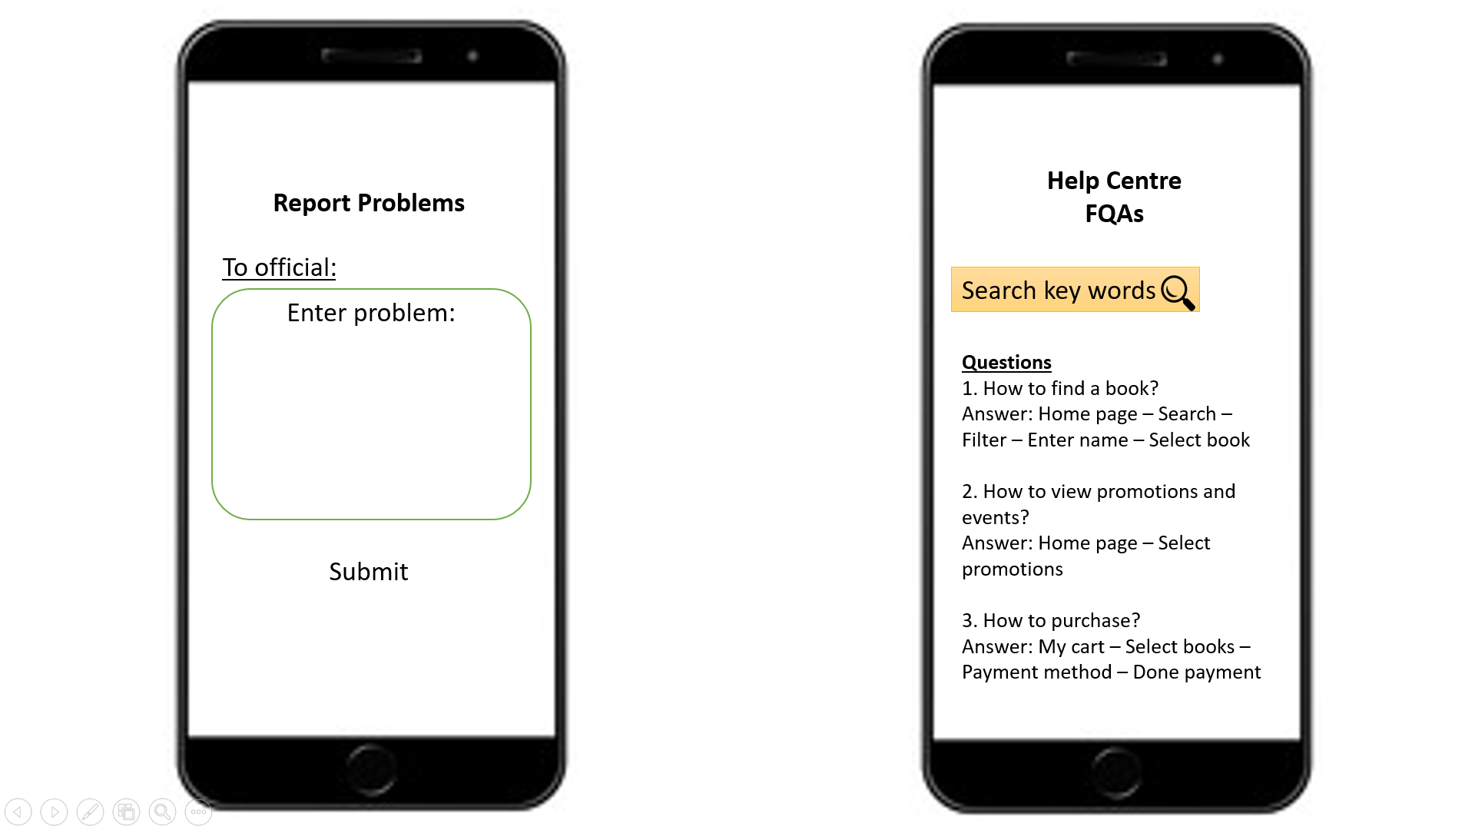

1. How to find help centre?

2. Which method to get help?

3. How to find reply from official?

4. How to report problems to official of platforms?

5. How to get answers of question in FAQs?